**Detailed Software Technical Design (DSTD)**

**For**

***VYNTRA MART***

**TABLE OF CONTENTS**

**1** **INTRODUCTION 5**

1.1 Purpose 5

1.2 Scope 5

1.3 Definitions, Acronyms and Abbreviations 5

**2** **ASSUMPTIONS** 5

**3** **PROJECT OVERVIEW**  5

4  **USECASE DIAGRAMS 6**

**5** **DETAILED DESIGN 7**

*5**.1.1 Navigation Map 7*

5.1.2 State chart design 7

*5**.1.2 Class Design* **8**

*5.1.3* Sequence design 9

**6** **DATABASE DESIGN** 10

6.1 Entity Relationship Diagrams 10

**Document Revisions**

|  |  |  |  |  |  |
| --- | --- | --- | --- | --- | --- |
| **Date** | **Version** | **Description** | **Author** | **Reviewer** | **Approver** |
|  |  |  |  |  |  |
|  |  |  |  |  |  |

**Information Handling**

These documents are strictly for **Virtusa/Client** use only. They shall not be shared with an external party other than the client concerned. These documents should always be kept securely and employees shall use reasonable care protecting these documents from unauthorized use or disclosure to a third party. This category also covers client intellectual property where Virtusa has a non-disclosure agreement with the client.

# 

# 1 **Introduction**

* 1. ***Purpose***

This document provides the detailed technical design for the VYNTRA MART and VYNTRA MART Application system.The goal of the application is ease of use and to provide interactive interface,extensive research has been done to gain an insight into needs.

* 1. ***Scope***

VYNTRA MART targets the online customers residing over the world.Secure registration and profile management for customers.Adequate searching mechanisms involved for searching products and services.Strategic data and graphs for administrators and dealers for most popular in each category and age group.

* 1. ***Definitions***
* **User** – The customer reviews about the type of earphone that are being available in the catalog online and purchase the product through payment gateway. Each user has a User ID.
* **Dealer** – Dealer add the stocks of various kinds of earphone of different brands using Seller ID.
* **Product** – It is the list that consists of all kinds of products.
* **Administrator** – The entire system is being managed by the administrator. It consists of removal of fake vendors.
* **Bank** – This is a kind of zone where the entire purchase payment takes place
  1. ***Acronyms and Abbreviations***

*ID – Identity number*

*SRS – Software requirement specifications*

*FC – Flow chart*

*MOBNUM-Mobile Number*

# 2 **Assumptions**

* The details related to the product, customer, payment and service transaction provided manually.
* Administrator is created in the system already.
* Roles and tasks are predefined.
* Internet connectivity during payment transactions will be high and secured.
* There will not be third-party access to the website during payment.

# 3 **PROJECT OVERVIEW**

# There are 3 kinds of actors in the project.

# Administrators:

# Administrators are the ones who adds or administers the categories for the products, and administers the Vendors

**Vendors/Sellers** :

Vendors/Sellers will add their products to the database, which will be seen in the website to the end users or say customers who can buy the products by selecting the one they need. Vendors will have the special privileges than the end users, and have ability to manage the products added by them.

**End Users/Customers**:

The end user will be the one who visits the website and buys products online from the ones added by the Vendors/Sellers.

**Bank:**

It handles Transaction process during payments.

# 

# 

# 

# 4 USECASE DIAGRAMS

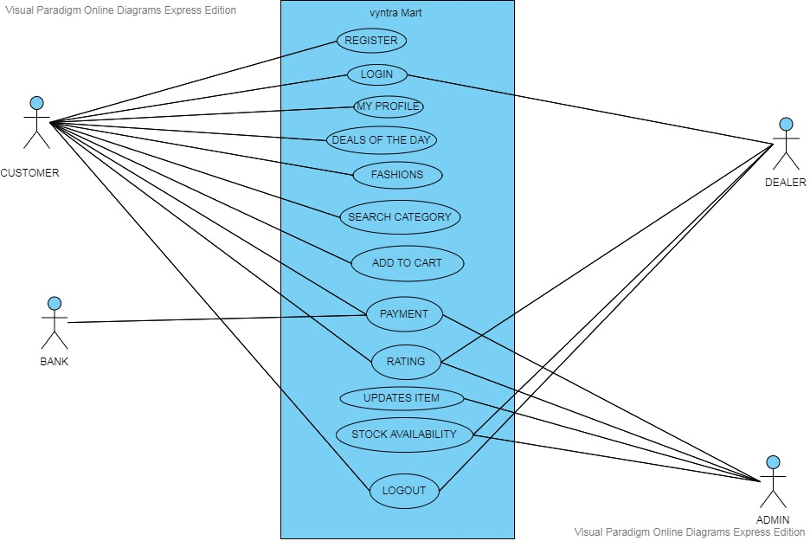

# 5 **Detailed Design for Module:**

### **5.1.1 Navigation Map**

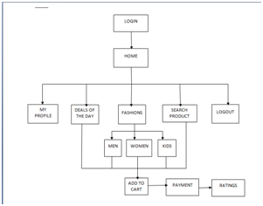

**5.1.2 State Chart Diagram**

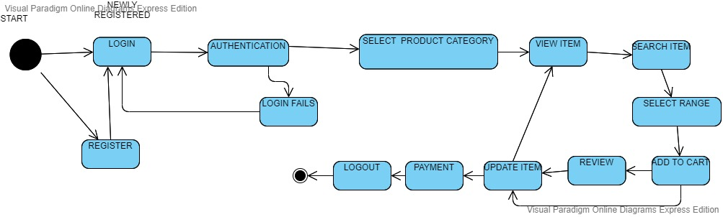

#### 5.1.3 *Class Design*

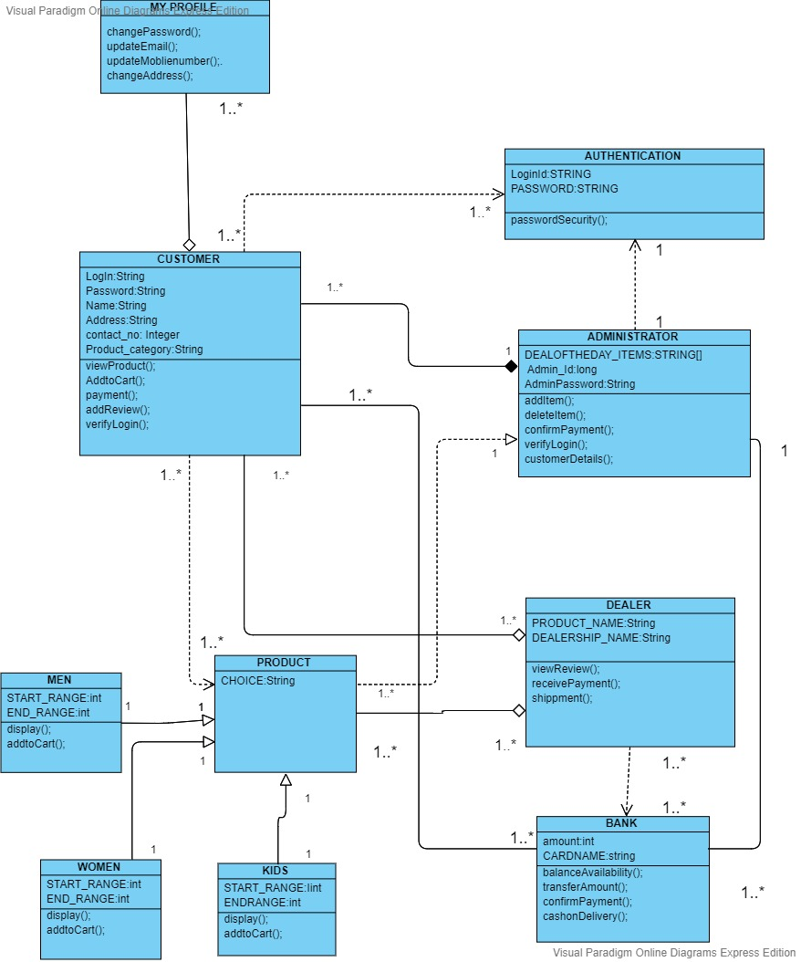

#### 

#### 5.1.4 Sequence Design:

#### 

# 6 **Database Design**

|  |  |
| --- | --- |
| **Models** | **Tools** |
| Database Entity Relationship Diagrams | ERWin |
| Object Models | Rational Rose |

***Entity Relationship Diagrams***

